Daniel Encarnacao

FIN 320 Project

Portfolio Management Tactical Asset Allocation Model

Tactical Asset Allocation is an investment strategy that focus on taking advantage of short-term opportunities to take lower risk and/or higher returns as opportunities present themselves in the market. The TAA strategy follows the ideology that, at least in the short-term, the market can misprice certain asset classes based in the short-term during economic, political, and/or social events that cause a certain asset class or industry to have a higher return for the anticipated risk, a lower risk for the anticipated return, these movements are often inversely correlated with other asset classes. TAA is described as “disciplined processes for evaluating prospective rates of return on various asset classes and establishing an asset allocation response intended to capture higher rewards” by Arnott and Fabozzi. A TAA strategy is meant to help investors achieve better-than-benchmark returns with lower volatility by varying short-term asset class exposure, allowing portfolio managers the ability to increase their margins. It’s important to note that the long-term asset allocation remains the same, TAA focuses on temporary shifts in asset allocation to improve returns and lower volatility. The TAA Strategy looks for asset classes where the risk premium are above normal levels anticipating a mean reversion, however, these often can take years, therefore portfolio managers have to have good judgement.

There are 11 asset classes in total from U.S Stocks to Volatility. Based on comparable models, the etfs below were put into groups based on asset classes and the etfs track those indexes in order to have the needed data to performer a comparable analysis on the returns of the indexes. The goal of this project is to find correlations and better understand the correlations of the different indexes and find movement indicators for each etf.

|  |  |  |  |
| --- | --- | --- | --- |
| **U.S Stocks** | **Foreign Developed Markets Stocks** | **Emerging Market Stocks** | **U.S. Governmetn Bonds** |
| SPY | IOO | EET | GOVT |
| QQQ | DE | VWO | SHV |
| DIA | VEA | SCHE | TLH |
| **Corporate Bonds** | **Emerging Market Bonds** | **Municipal Bonds** | **Treasury Inflation-Protected Securities** |
| PICB | EMAG | HYMB | ZROZ |
| SPXB |  | VTEB | TIPX |
| **Real Estate** | **Commodities** | **Risk Parity** |  |
| RWO | DBC | TR |  |
| SCHH | GCC |  |  |

The data set for this project will be extracted from Yahoo Finance and will consistent originally of daily closing prices from our selected index-tracking etfs. The data was adjusted differently for different parts of the research however below is a list of the lambda functions which I used to extract and manipulate the date to fit the three different models that I used. The first model takes an input of the average daily return percentage for each etf and it calculates the abnormal results in the data sets. The second model takes the data set without the outliers as an input to calculates the correlation between the different etfs. The second model was used to observed different data sets and changed accordingly to help us understand our results.

The first model was designed to identify the outliers within a data set, meaning the returns that were too abnormal. Our model was altered to fit the data set’s structure and the desired results. The model follows a z score method to identify which returns are abnormal by calculating how many standard deviations the result was from the mean of the data set The purpose of this model is to first gather these outliers to further research them and understand when and why they are happening. As the results were evaluated, a common trend was found amongst abnormal results in various of the etfs around the beginning of each fiscal quarter, likely due to earnings season. The other purpose for identifying the outliers in the data set was to remove them from the data so that we can better examine the data. This model is an important part of assuring the results of the following model are as accurate as possible.

The following model takes the data sets created by the previous model and it uses them to calculate the correlation between the different data sets. The model was design so that different parameters can be changed as needed for our research and we took that to our advantage. First, we examine the correlation between the daily returns of the 24 etf tracking indexes. Then we adjusted the model to find the correlation between the returns without the outliers, identifying the outliers using a z score. The model analyzed data calculating the z score based on the mean as well as based on the median. Also, the model was fitted to analyze outliers as 2,3, and 4 standard deviations from the mean and median. The results show lower correlation between the indexes when you remove the outliers at 2 and 3 deviation from the mean or median, likely because a lot of the correlation comes from the cyclicality of business, such as quarterly earnings reports and economic reports released throughout the year that, especially in times of high volatility, carry a lot of speculation and estimates with them.

The results from analyzing the correlation between just the outliers was supportive of our previous results. For example, the results from analyzing the correlation of the outliers 2 standard deviations from the mean was not very reviling, however, when we examined the correlation of the outliers 3 standard deviations from the mean we got strong results, supporting some of the correlations examined in the original model using the daily average returns. Moreover, this correlation between outliers indicate a correlation of large movements in either direction suggesting that similar correlations indicate markets in similar business cycles and vice versa. When the data was analyzed with the outliers measured 4 standard deviations away from the median and mean we observed similar results as before.

The results suggest strong correlations between the short-term movements of the different indexes. The results show some strong correlations of outliers such as the positive correlation of outliers for the tax-exempt bond index etf (VTEB) and the US treasury STRIPS index etf (ZROZ.) In the data from the daily returns, it can be observed that the two indexes are correlated. On the other hand, you have the outliers of municipal bond index etf (HYMB) and tax-exempt bond index etf (VTEB) that have strong negative correlations, but the indexes’ daily return correlation is a strong positive correlation. There are some patterns between some indexes and further researching each index into more sub-indexes would create more, stronger correlations.

After having corrected my model to remove outliers without messing the correlations I was able to see better results and stronger correlations than previously. Using quantiles instead of standard deviations also helped sort the data better. Examining the correlation over time was extremely helpful in determining how correlations have changed overtime. For example, by examining the correlations of both GOVT and IAU with SPY, I was able to see how as the GOVT becomes more negatively correlated to the SPY the IAU becomes less negatively correlated and vice versa. Below you can see the heatmap correlations of the data without the outliers follow by the heatmap correlations of the outliers. This new analysis demonstrates the strong correlations seen previously more clearly. You can see how the outliers have a very strong correlations while the rest of the data has much lower correlations, indicating that most of the correlations might be occurring during these outlier periods, or abnormal return periods. This likely validates a possibility for a strategic asset allocation strategy to outperform the market.

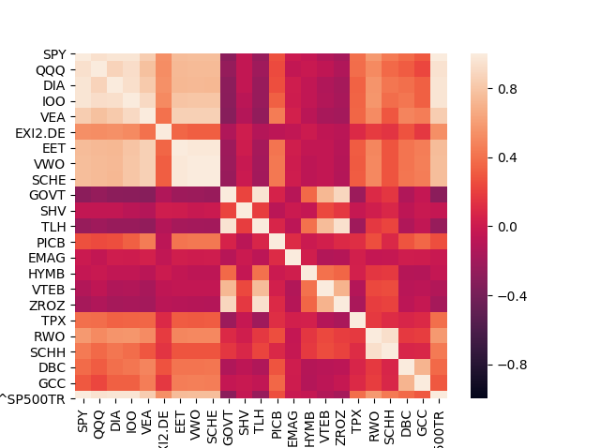Correlation of Index Tracking ETFs without Outliers (Volatile Returns)

Correlation of Index Tracking ETFs Outliers (Volatile Returns)

